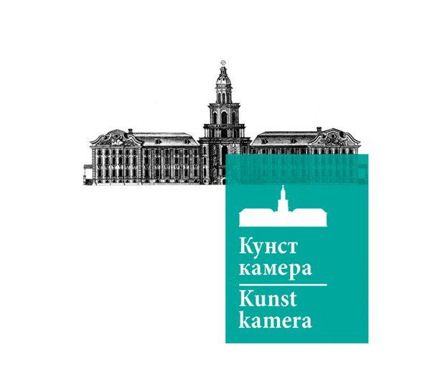
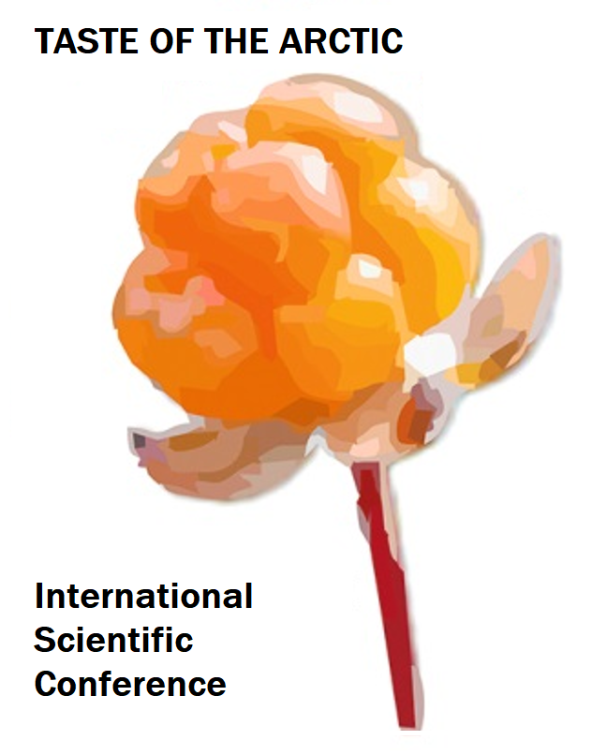
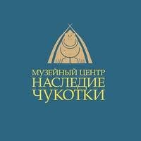
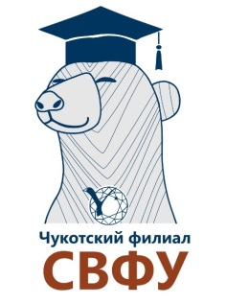
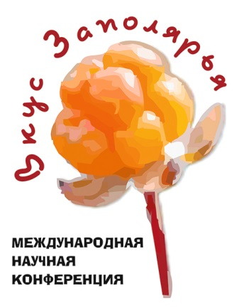
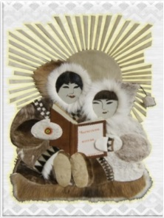

On April 20-21, 2023, the International Scientific Conference "Taste of the Arctic" will be held in Anadyr, Russia

The conference aims to discuss various aspects of food practices, food supply and understanding of taste in the Arctic.
We plan to speak about a whole range of issues related to the technology of cooking, the nutrition traditions, diets, the transformation of eating habits, ideas about satiety, taste and smell of food.
We will address the issues of food supply to remote settlements; traditional food as a tourist product and new recipes; field-work methods and impressions, language aspects and specific terminology related to nutrition.
The problem of local food production, as well as the use of new technologies for cooking and storage, will be considered.
The conference will involve a range of scientists - specialists in the field of ethnography, anthropology, linguistics and indigenous people of the Arctic - experts in traditional culture. Leading scientists in the field of anthropology of nutrition, who worked in other regions of Russia and the world, were also invited, which will make it possible to identify a number of key problems in this field of knowledge. It is planned to discuss a number of practical and theoretical issues related to the study of the “materiality” and “spirituality” of the interrelated processes of obtaining, producing and consuming food products.
As part of the conference, the Museum Center “Heritage of Chukotka” will also host an exhibition dedicated to the traditional cuisine of the indigenous peoples of the Arctic. It will include more than 40 photographs and notes made by young scientists from St. Petersburg and Anadyr, revealing the features of the traditional alimentary culture of the indigenous inhabitants of the Arctic North. The exhibition will be complemented by items from the ethnographic collection of the Museum Center “Heritage of Chukotka” – tools and crafts, dishes, devices for making fire and cooking.
The conference will include an exhibition and tasting of traditional dishes of the indigenous peoples of Chukotka.
The conference is held jointly by Peter the Great Museum of Anthropology and Ethnography (Kunstkamera) of the Russian Academy of Sciences, Chukotka branch of the M.K. Ammosov North-Eastern Federal University and the Museum Center “Heritage of Chukotka”.

